


www.nnr-scotland.org.uk www.tentsmuir.org


TENTSMUIR NATIONAL NATURE RESERVE

NEWSLETTER No. 23

JUNE 2010

Welcome to the summer edition of the Reserve Newsletter. And what a busy year we are having already! So much going on in the Reserve sites and so much has been observed. It is an important year as it’s the International Year of Biodiversity 2010 – No Biodiversity No Breakfast! Read on inside.

Heard a cuckoo yet? Did you manage to spot the magnificent sea eagles? Have you observed and heard the chiff chaff, wheatear, waffling green woodpecker, the drumming great spotted yet?? They are all around us at the moment.

What’s coming up very soon? Yes it’s the brilliant annual Family Day event – “A bloomin’ great day out” read on inside.

What else is going on in this edition? The tremendous, which is a bit of an understatement, the amazing foreshore changes. How many tsunamis did hit the east coast? Once again the last six months have seen a tremendous amount of management and monitoring work carried out; have the seals returned? All will be revealed.
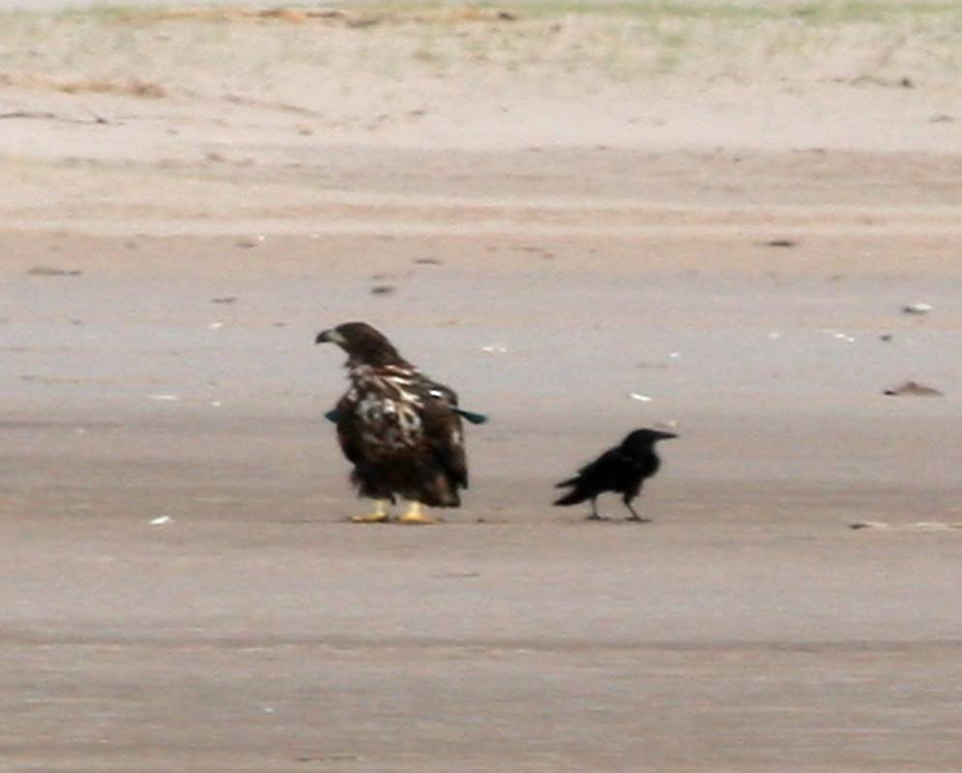

Sea Eagle and the crow Image by kind permission from Marek Malecki

Tom Cunningham
Reserve Manager
TENTSMUIR NATIONAL NATURE RESERVE

Biodiversity is our life
2010 has been declared the International Year of Biodiversity (IYOB 2010) by the United Nations.

Biodiversity is the variety of life on Earth. It is essential for sustaining the natural living systems or ecosystems that provide us with food, fuel, health, wealth, and other vital services.
Humans are part of this biodiversity too and have the power to protect or destroy it. Currently, our activities are destroying biodiversity at alarming rates. These losses are irreversible, impoverish us all and damage the life support systems we rely on. But we can prevent them.
We need to reflect on our achievements to safeguard biodiversity and focus on the urgent challenges ahead. Now is the time to act.

Biodiversity will be the theme for the year Family Day Event so book in and come along and see what we are hoping the visitors can do themselves for biodiversity.

TENTSMUIR POINT

We had an exciting time with three juvenile white tailed sea eagles hanging around for six weeks or so Marek Malecki managed to catch them on his camera and one image graces the front cover and it has a comical slant to it. Many thanks to Marek and also to Jacqui Herrington for providing me with lots of brilliant images.

A local lady who wishes to remain anonymous has collected well over a hundred bags of rubbish, walking out of Tayport heading along the foreshore and on Tayport Heath and around Tentsmuir Point, what a wonderful gesture and many thanks.

One hundred employees from Shires Pharmaceuticals from Basingstoke enjoyed a sunny afternoon out. After the guided walk they litter picked a massive amount of rubbish including vehicle wheels, fishing net and discarded containers filled with old oil. Said manger Lindsay:
“The entire Shire group found the afternoon at Tentsmuir Point fun and interesting. The guides were excellent and the setting absolutely beautiful. It was great to be able to litter pick so that not only did we get to see the stunning scenery and wildlife but also to 'give something back' and help keep the beach clean. The Reserve staff were really helpful and added to the trip by giving useful information on the area, history and wildlife. The seal colony was a special treat with their inquisitive nature as 100 of us invaded their beach! Thanks for making it a fantastic day.”

MANAGEMENT

The Limousine cattle were brought back in recently to continue grazing over the summer months. This brilliant valuable working relationship with Robert Lamont of Scotscraig Farm has benefits to both parties, grazing for us and a nearby site for Robert to check his cattle with relative ease. Along with the herbicide spraying management the cattle will help to reduce the tree and scrub growth and open up the thicker grassy sward. Watch out for the herd as they sun themselves on the foreshore, appreciating the sea breeze keeping the pesky flies off them.

The new wind generator and solar pump system was installed replacing the wind pump on the Great Slack and it worked well over the latter part of winter. Along with the solar borehole cattle drinking trough system we have quite a green sustainable power system on the site.

The annual maintenance of the sea fences took place in Spring after the high tides and Bob Ritchie and his team replaced many of the missing posts and wire. With health and safety in mind the guys had a standby tractor waiting just in case, such was the soft sand and silt conditions in this area.

Many other management tasks were undertaken and included fence maintenance and hand pulling the many pine seedlings that try and grow in the heath and dunes. The crow and grey squirrel controls were successfully carried out and already we can see and hear the many ground nesting birds on the site, read on below. Shortly the ongoing annual herbicide treatment of the target species (mainly all tree species, gorse and broom) will start.

THE DYNAMIC COASTLINE

The transformation of the foreshore and dunes has again been breathtaking as well as awe-inspiring. In the grand scheme of things over the thirteen years that I have been working here the changes are just incredible. We lost a few metres of dune edge in the north dune edge although the thin finger of dune still builds further into the River Tay. From the middle foreshore area the loss was slightly less. However, the storms and gales blew sand and flotsam some 90 metres in land. In the WWII Command Post (formerly known as the green hut) area the outflow channel changed direction and now flows out to sea further south. As a result the foreshore build up has to be seen to be believed.

Remember that slack jaw open mouth feeling? Colleagues as well as visitors have been known to carry out that same action when taking in the new sculpted landscape. The foreshore build up is massive. To the south the dune accretion is monumental, Alex and I measured it and it was 314 metres from the 1997 high water line, the year I started working on this wonderful place.

The stormy high tides in early Spring washed sea water and flotsam half way down the icehouse to foreshore footpath, it really is incredible. (I’ve run out of clichés!) Along with the natural flotsam the whole area was awash with tons of rubbish, which was probably floating around on the oceans for many years. Disappointingly there were discarded fishing nets, large amounts of containers filled with probably old ships engine oil. How irresponsible is that?

EDUCATIONAL VISITS

Schools continue to use Tentsmuir Point with High schools as far away as Lochgilphead and Tarbet enjoying their study days out. Elmwood College continue to use the site as an excellent location to study conservation management and already we have several primary and high schools booked in for the next few months.

Remember anyone can look at the second edition of the Education Pack on line and use any of the interesting activities.

WILDLIFE UPDATE

Grey partridge were recorded on the Great Slack area which must be a first for many years. The excitement rose as we observed the young white tailed sea eagle which hung around for a few months, was then joined by another two juveniles. It was an amazing sight to see the three wheeling about above us.

Swallows have been back for some time now, these aerial acrobats are great to watch. Skylark song fills the air and you can hear the calls of the wheatear, meadow pipits and we have heard cuckoo calling along the Ice house area.

My grateful thanks go to Bill Alexander and Paul & Ruth Blackburn who continue to carry out the monthly observations along with our staff observations when we are out and about.

Moth and butterfly expert Duncan Davidson provided several snippets form his Butterfly newsletter:
“A single Green Hairstreak was spotted on one of the Tentsmuir transects in the second last week of April, which I think is the earliest Fife record I have, certainly for the last five years.”
“On one of my visits to Tentsmuir NNR last year I caught a Garden Tiger Moth that left me with a clutch of eggs on one of the egg cartons in my trap. Imagining the fantastic prospect of having 150 adult Garden Tiger Moths to photograph, I decided to keep the eggs and raise them to adulthood. It wasn’t long before I had around 150 tiny, hairy pets; they feed on dock, dandelion, bramble and a variety of other common plants and so it was not hard to keep them well fed. However it quickly became obvious that I had taken on more than I could handle: I had separated them into boxes with ten caterpillars in each and every box had to be cleaned and replenished almost daily. So once again I found good homes for some and then I released the rest back in Tentsmuir, keeping just ten for myself. One of the difficulties in rearing these creatures is how to ensure they survive over winter – I am told that 90% mortality in captive populations is common. Many “breeders” will keep them warm and feeding continuously thus avoiding hibernation altogether. Survival rates are good, but of course the adults will emerge at completely the wrong time of year. When my ten started to get a bit sluggish I put them in a clean box with scrunched up kitchen roll and no food and kept them in the back of my car (the car has no heating and so was a reasonable facsimile for the frosty outdoors!). I am pleased to say that all ten survived, wakened up in late March and are now fully engaged in rapid growth. I am looking forward to seeing them pupate in late June and hopefully emerging a month later.”

Already the butterfly season has been very good with excellent numbers of orange tips, peacock, green veined white, small white and small coppers. Excitement mounted as first volunteer butterfly surveyors Gillian Fyfe and then Daphne MacFarlane Smith both observed a green hairstreak. Ailsa Malcolm recorded comma once again and even had one land on her arm.

MORTON LOCHS

MANAGEMENT

In a very busy period my colleague Alex, contractors, foresters Graham Paul & John Murray, along with volunteers Iain Jamieson & Eve Schulte and occasionally Elmwood College Conservation students, continued the mammoth task of scrub cutting the gorse and broom and then burning the brash on Garpit Moor (formerly known as the north plantation). This is a huge task and a lot of work in one large area as we continue to control and eliminate this ubiquitous plant throughout the site.

A new plot was prepared and heather seed spread throughout to continue to manage the site and return this once forest plantation to a heath. The heather previously seeded on prepared plots two and three years ago continue to grow albeit rather slowly.

Contractor Dave Mackie and team will start shortly as we continue the annual herbicide spraying of target species including the rampant bracken, other target species and the reeds in the lochs. This will be the eighth year the team have worked on site and the tenth year since we started all this management.

The Scotscraig Farm Limousine cattle came back on site during May and they will graze throughout as part of the management of the site. Once again I am grateful to Robert Lamont, sons Rob and John and cattleman Jock.

Visitor feedback on the new Fullerton bird hide stair and the new cushion pads on the hide seats have been extremely favourable.

The Morton access road has suffered from the wet and hard packed ice cover over winter and the potholes will soon disappear again when the Forestry Commission will regrade the track surface in June.

WILDLIFE UPDATE

My colleague Sarah Eaton completed her research as to why the teal numbers are dropping at Morton Lochs and a short conclusion is provided:

“Teal (Anas crecca) is a species of duck which is a notified feature of interest at Morton Lochs Site of Special Scientific Interest (SSSI) in Fife. The lochs once supported two per cent of the national non-breeding population, but in 2003 monitoring showed a decline of 35.5 per cent in the population at the site, which is not aligned with the national trend.
The lochs have a complex hydrological history, with extreme fluctuations in water levels. Previous research has highlighted the importance of maintaining specific water depths for wildfowl.
Teal were observed and counted once a week over the winter of 2009/2010. Water levels and other environmental factors were recorded and existing data were collated.
Regression analysis of primary data showed no correlation with teal numbers and water levels, or with other environmental factors. An analysis of mean teal numbers versus average water levels over winters 2004/2005 to 2008/2009 showed a strong negative correlation.
Although teal are known to be susceptible to cold weather, there was no relationship between teal numbers and temperature, even during the very cold winter of 2009/2010.
It is suggested that lowering water levels in summer and raising them again in autumn may improve conditions for teal, a regime used successfully in the USA and France. A further, longer period of research could establish the success or otherwise of such a management technique at Morton Lochs.
Peak counts have indicated considerable and irregular peaks and troughs in the Scottish wintering populations of teal. The analysis of counts from Fife Bird Reports showed that other water bodies had also experienced changing teal populations.
Ultimately, it may be necessary to accept that the decline in teal numbers at the site is part of the wider picture of fluctuations in non-breeding teal populations.”

There have been some rare observations and great sightings and a first for me around the Lochs. The male swan with a darvic ring JSH is now in his second year here and along with a mate settled in and built a nest. We await the hatchlings and they must be due around now.

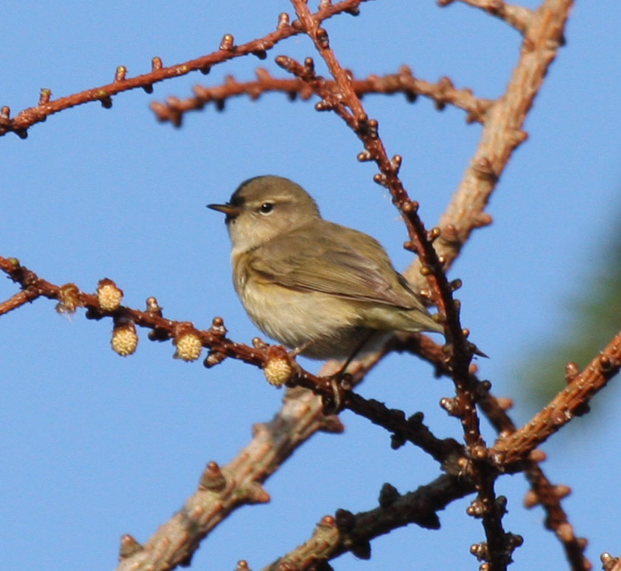

Chiff chaff at Morton Lochs. Image kindly provided by Jacqui Herrington

IRRESPONSIBLE VISITORS
Fife Police have launched a new initiative called community engagement initiative where a local policeman will be community based. Already the local police officers have taken up issues and have acted as quickly as they can i.e., dog poo, dogs off the lead, etc.
I continue our message for all dog owners: please be responsible and ………..

BAG IT. TAKE IT HOME TO BIN IT!

KIDS CORNER

Well, it didn’t take off as much as I’d hope so I will extend the poetry funny story competition.

If anyone has a child who would like to write a few lines about what they think of their day out on the Reserve please let me know, email or write me a story about what you saw, how you felt, or if there anything you would like to do or see on the Reserve sites?

To encourage you we’ll have a competition with a £10 book token for the prize. Write a poem about the Reserve or your visit to the Reserve. The winner will receive a £10 book token and the best poems will be in the next Newsletter. Competition closes on the 30 August 2010.

VISITORS & VOLUNTEER
Congratulations to work experience student and volunteer Eve Schulte who was awarded the Elmwood College student of the year in HNC Conservation Management. Congratulations also to Iain Jamieson, now in his third year of volunteering here successfully gaining employment with SNH at Loch Leven NNR. Both brilliant achievements and we wish them all the success in the future – of course welcoming them back with open arms at any time.

Volunteer Pete Cunningham kindly provided this poem:

Open Day On the Reserve

The alarm clock sounds its soft gentle ring, but Tom was awake - heard the dawn chorus sing.
He has seen every hour since a quarter to three and goes down to the kitchen for a cup of hot tea.
Then ready for work he jumps in his van and heads off to Tentsmuir – one mission - one man!
The office is noisy; the volunteers are here, meeting with friends they saw this time last year.
The marquee is running a little bit late and the portaloo man is stuck at the gate so Tom rushes off to let them both in and waves them both through with a bright cheery grin!
Then off to the ice house and up the long track where gleaming white canvas will billow and crack.
Soon it is standing all neat and four square then filled up with tables and blue folding chairs.
Back to the office then the icehouse again and Tom offers a prayer, ‘Oh don’t let it rain.’
(He’d organised sunshine for the last ten years and he doesn’t want this one to end in tears!)
The buses arrive and Tom gathers the folks with his short welcome speech and funny old jokes.
‘The wee creepy crawlies are all part of the deal! Go on a bug hunt or search for the Seals.
Paint a picture with Davy with his artistic cool, and sit in the sun on a round wooden stool.’
A guided walk is part of the fun and everyone’s happy in the hot Tentsmuir sun.
The sessions are finished; hot coffee and tea, and cakes from the baker one for you two for me!
Dr Bunhead brought mayhem with his chemical fire; his head was in flames rising higher and higher.
The day came to a close with an exploding cloud - I don’t think I’ve heard anything so loud!
Tom stood like a general when the battle is won and his mind was free -and he’s heading home now for a long G and T!
You’d think he’d relax but what’s this I hear? He’s wondering how to surpass this next year!!

WHAT’S ON

FAMILY DAY OUT - Thursday, 8th July 2009 - “A bloomin’ great day out”.

The eleventh free annual NNR event will be held on Thursday 8 July and it should be another exciting day out. The event will celebrate the 2010 International Year of Biodiversity and through some freebies we will help everyone to learn more about it and encourage everyone do their bit for biodiversity everywhere.

The new style shorter activity sessions will continue, so cram as many of the activities in and learn all about biodiversity and what goes on in the Reserve. So please be patient, enjoy, learn and try several different ones. Each activity will last 20 to 30 minutes; you finish one and then move onto the next one. Staff and volunteers will help you move on.

In addition to the short events and activities in store for you, we have the very special guests the Puppet Lab from Edinburgh to entertain you with a Biodiversity themed puppet show.

Once again there will be tea, coffee, fruit juice and a biscuit, maybe!

The activities include:

- Origami and painting birds heads with Dave Mitchell.
- Bugs Bonanza Biodiversity.
- Local Giant of the Sky.
- Nature treasure trail.
- Nature Fun for the under fives.
- White tailed sea eagle activity.
- Tentsmuir on a Twig.
- The viewpoint telescopes and all the staff and volunteers will be happy to answer your questions and help you enjoy the day out.

With the exception of the £1 charge for the car park, it’s all free!

There are 120 places available and the event books up fairly quickly. I also keep a reserve list, as there is usually a visitor or two who may have to cancel suddenly. If you are unable to attend after booking, please contact me as soon as possible to let me know, so I can call and let someone else take up your place. Please don’t let me or other visitors down. Remember all children must be accompanied by a responsible adult.

To book, please phone my office telephone and if I am not in, please leave a short message on the answer machine, with your name and telephone number and I will contact you to confirm the booking. If I do NOT contact you, you are not on my list!

WALKS & TALKS

Want to know more of what we do, or just want to see the wonderful sights on the Reserve? If you have a few friends or a group who fancy a guided walk or talk about the Reserves, please contact me. If you would like to see how effective the management of the Reserve is, or observe a little more of the hidden secrets and gems, then give me a ring and I will arrange a guided walk or talk.

I look forward to seeing you on the Reserve sometime.

BIG THANKS

Many thanks to all who contribute to the Newsletters and the valuable data collected for our flora and fauna records and to the local newspapers for articles. Finally, a very BIG personal Thank You to all the Reserve staff, honorary wardens, volunteers and visitors who put in a lot of time and effort, provide wonderful information, wildlife data and images without which we would not produce such great results.

Enjoy your visits to all the sites in the Reserve. Take away only memories and images and leave behind only your footprints.

Tom Cunningham.
Reserve Manager
Fetterdale Office
Tentsmuir Forest
By Tayport.
DD6 9PF

Tel/Fax/Answer machine. 01382-553704.
Email: tom.cunningham@snh.gov.uk

PS The reaction from the Raith Rovers reports has been quite amazing, even people who have no or little interest in footie say to me “how’s the Rovers doing?” At the moment it’s another Rovers rollercoaster time, we reached the Scottish Cup semi-final and we survived in the First Division, enough said! My Area Manager mentioned that I never mention Ayr United, well Iain, you were relegated – ooops.

Be aware of ticks in the UK countryside and elsewhere in Europe. This is a message from all the responsible environmental organisations in the UK who are aware of the rise in the number of ticks in our countryside. All visitors to our countryside should really examine themselves and check for ticks as soon as you can. If you do happen to have one attached remove it as soon as you can. To guard against ticks: Keep trousers tucked into socks and wear light coloured clothing. Examine your body for ticks in the backs of the knees, groin, under the arms and on the scalp. Dog owners should also check their dogs. Stay safe, be aware.
Know the Code Before You Go, its well worth getting a copy of this useful guide from SNH and now there are activity guides you can use for your children. For more information have a look at: www.outdooraccess-scotland.com/educationresources
Useful websites: www.snh.gov.uk www.nnr-scotland.org.uk and www.tentsmuir.org for information on the Reserve and surrounding area as well as our work in SNH,

Have a look at www.placebookscotland.com and put your own images, stories and poems on this new website, it’s yours to use and put all your favourite places on it, including Tentsmuir NNR!

